LAPORAN PRAKTIKUM
WORKSHOP KECERDASAN BUATAN
BAB 2



PANDU WINATA KRISNA PUTRA
5324600003

PROGRAM STUDI SARJANA TERAPAN
TEKNOLOGI REKAYASA MULTIMEDIA
JURUSAN TEKNOLOGI MULTIMEDIA KREATIF
POLITEKNIK ELEKTRONIKA NEGERI SURABAYA
2026

Example 2.1
#Example 2.1
print("Hello World!")

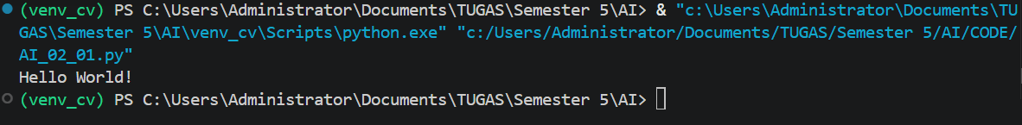
Example 2.2
#Example 2.2
'''
This is a multiple line
comments.
'''
print("Hello World")

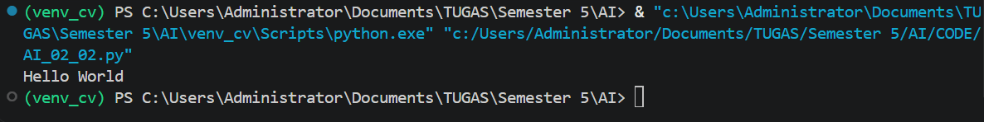
Example 2.3
#Example 2.3
a = 5
b = 7
c = a + b
print("c = " , c)
d = 'x'
e = 'y'
print(d + e)
f = "Hello"
g = "World"
l = f + " " + g
print(l)

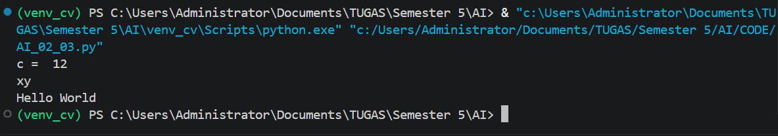
Example 2.4
#Example 2.4
for i in range(5):
print(i)
print("Finished")

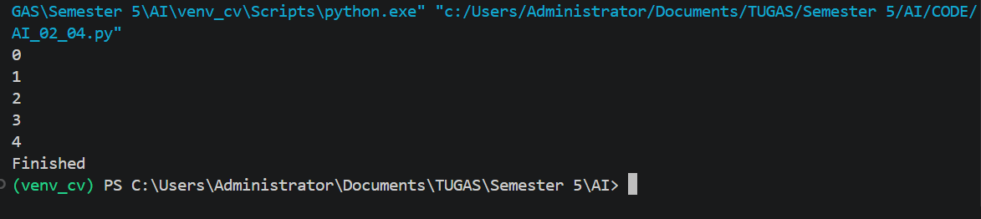
Example 2.5
#Example 2.5
for i in range(5):
for j in range(5):
x = i * j
print(x)
print("Inner Loop Finished")
print("Outer Loop Finished")

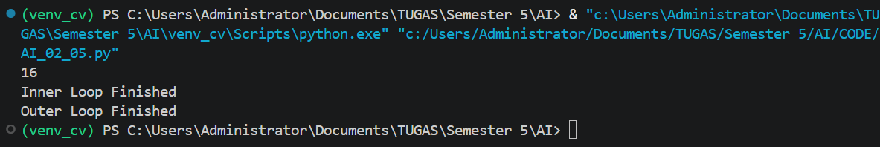
Example 2.6
#Example 2.6
x = 0
while x < 5:
x = x + 1
print(x)
print("Finished")

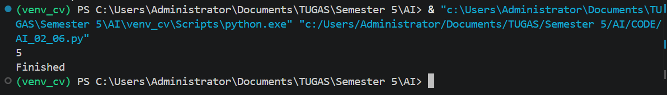
Example 2.7
#Example 2.7
x = 100
if x >= 70:
print("Excellent")
elif x >= 60:
print("Good")
else:
print("OK")

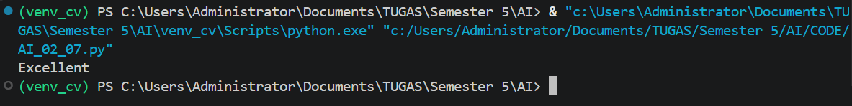
Example 2.8
#Example 2.8
def add (x,y):
z = x + y
return z
t = add(30, 20)
print(t)

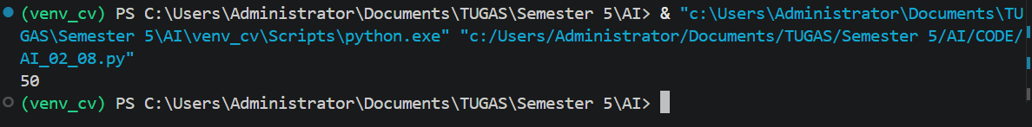
Example 2.9
#Example 2.9
def maxarray (xs):
m = xs[0]
for x in xs:
if m < x:
m = x
return m
data = [0,1,2,3,4,5]
t = maxarray(data)
print(t)

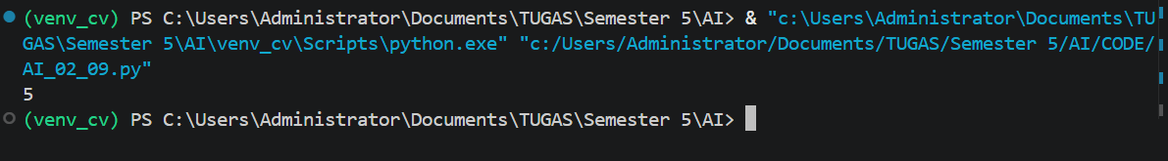
Exercise 2.9.1
# Exercise 2.9.1

def minarray(xs):
m = xs[0]
for x in xs:
if m > x:
m = x
return m

data = [0, 1, 2, 3, 4, 5]
t = minarray(data)
print(t)

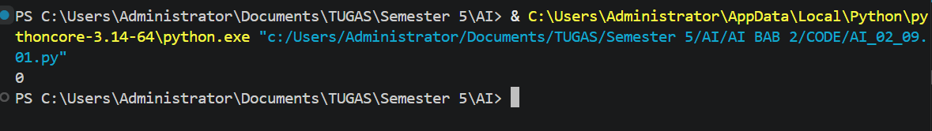
Exercise 2.9.2
# Exercise 2.9.2

def sortarray(xs):
xs.sort()
return xs

data = [5, 2, 4, 1, 3, 0]
t = sortarray(data)
print(t)

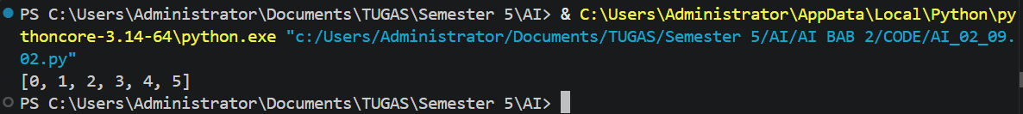
Example 2.10
#Example 2.10
print('What is your name? ')
x = input()
print('Hello ' + x + "!")

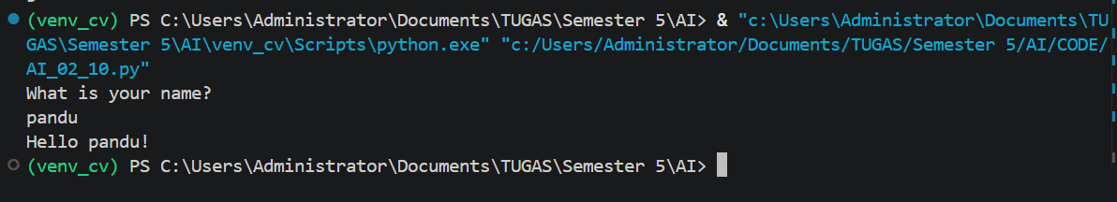
Example 2.11
#Example 2.11
print('Input a number: ')
x = input()
y = int(x)
y = y ** 2
print('The square of ' + str(x) + " is " + str(y))

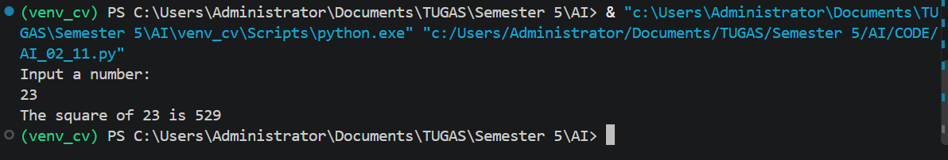
Exercise 2.11.1
# Exercise 2.11.1

print('Input a float number: ')
x = input()
y = float(x)
y = y ** 2
print('The square of ' + str(x) + ' is ' + str(y))

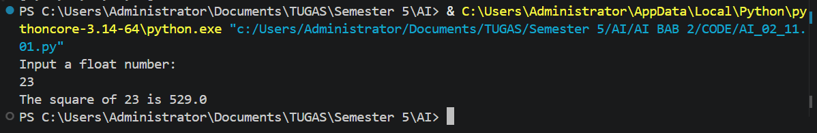
Exercise 2.11.2
# Exercise 2.11.2

print('Input your name: ')
name = input()

print('Input your age: ')
age = int(input())

print('Input your marks: ')
marks = float(input())

print('Name: ' + name)
print('Age: ' + str(age))
print('Marks: ' + str(marks))

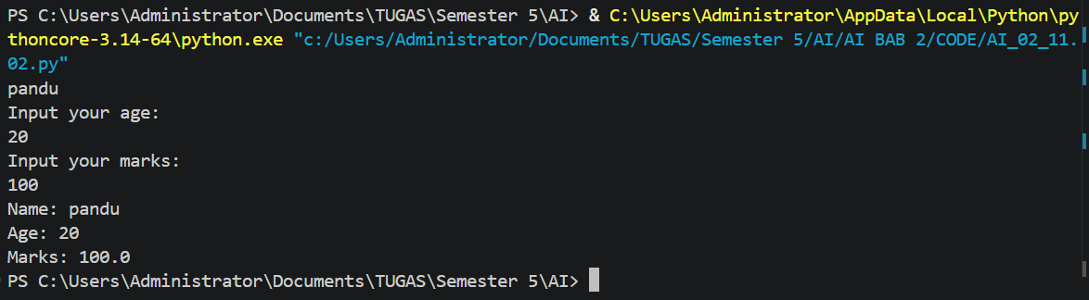
Example 2.12
#Example 2.12
s = input("Input a list of numbers: ")
numbers = list(map(int, s.split()))
print(numbers)

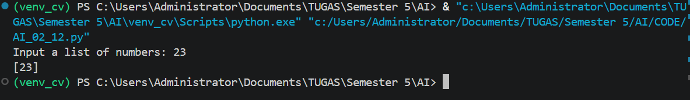
Example 2.13
#Example 2.13
import math
r =5
cir = 2 * math.pi * r
print('The circumference is ' + str(cir))
x = 5
y = math.sqrt(x)
print("The square root of " + str(x) +" is " + str(y))
x = 7
y = math.factorial(x)
print("The factorial of " + str(x) +" is " + str(y))
x = 16.4
y = math.floor(x)
print("The floor of " + str(x) +" is " + str(y))
x = 16.4
y = math.ceil(x)
print("The ceiling of " + str(x) +" is " + str(y))

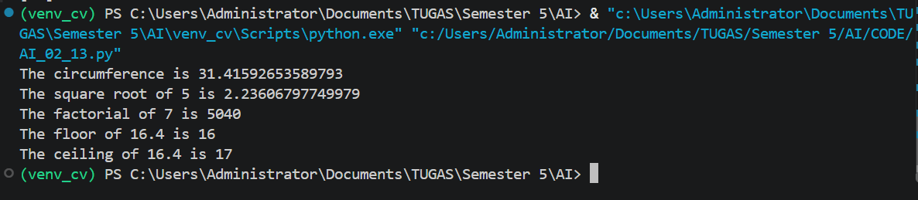
Exercise 2.13.1
# Exercise 2.13.1

import math

print('Input a list of float numbers:')
numbers = input().split()

for x in numbers:
x = float(x)
y = math.sin(x)
print('The sine of ' + str(x) + ' is ' + str(y))

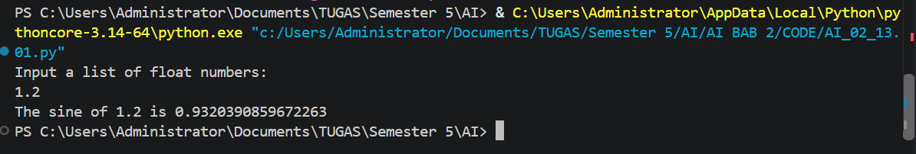
Example 2.14
#Example 2.14
import matplotlib.pyplot as plt
import numpy as np
x = [i for i in range(100)]
x = np.array(x)
x = 2 * np.pi* x * 0.01
y = np.sin(x)
plt.plot(x,y)
plt.title('Sin Plot')
plt.xlabel('x')
plt.ylabel('Sin')
plt.show()

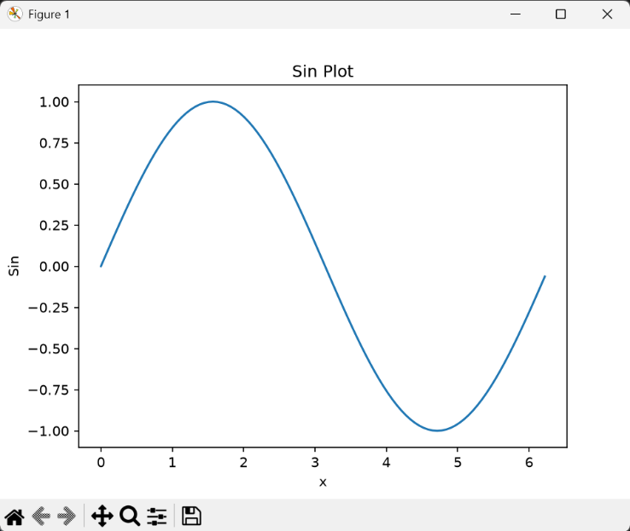
Example 2.15
#Example 2.15
import numpy as np
import matplotlib.pyplot as plt
x = np.linspace(-np.pi, np.pi, 50)
y1 = np.sin(x)
y2 = np.cos(x)
plt.plot(x, y1, color = 'blue', marker = "s", label='Sin')
plt.plot(x, y2, color = 'red', marker = "o", label='Cos')
plt.legend()
plt.show()

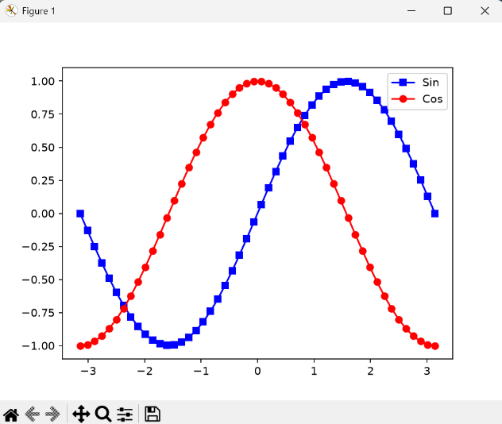
Exercise 2.15.1
# Exercise 2.15.1

import numpy as np
import matplotlib.pyplot as plt

x = np.linspace(-10, 10, 100)

y1 = 3 * x + 4
y2 = 2 * x**2 + 1
y3 = x**3 + 9

plt.plot(x, y1, color='blue', label='y = 3x + 4')
plt.plot(x, y2, color='red', label='y = 2x^2 + 1')
plt.plot(x, y3, color='green', label='y = x^3 + 9')

plt.legend()
plt.show()

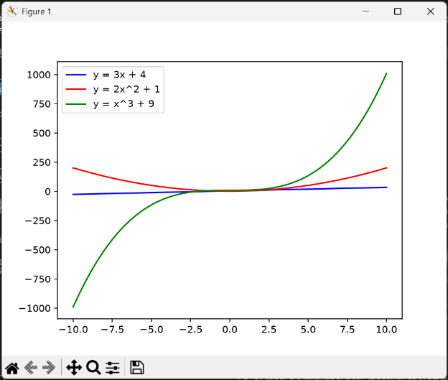
Example 2.16
#Example 2.16
import pandas as pd
data = {'Name': ['Tony','Robert','John','Alice'],
'Age': [18,24,19,21],
}
df = pd.DataFrame (data, columns = ['Name','Age'])
print (df)
df.to_csv('test.csv', index=False)

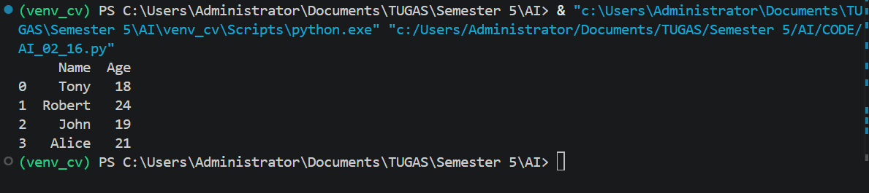
Example 2.17
#Example 2.17
import pandas
df = pandas.read_csv('test.csv')
print (df)

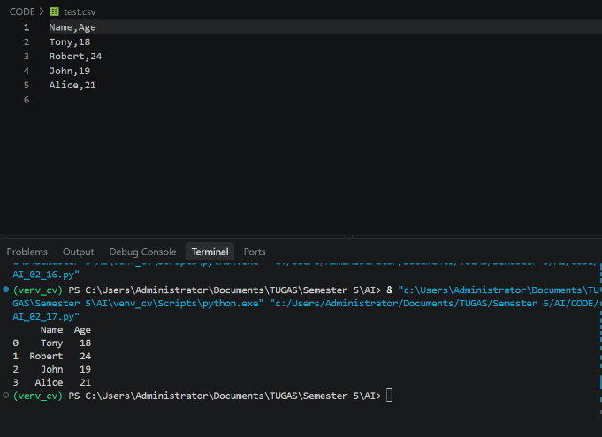
Example 2.18
#Example 2.18
#pip install xlsxwriter
import pandas as pd
data = {'Name': ['Tony','Robert','John','Alice'],
'Age': [18,24,19,21],
}
df = pd.DataFrame (data, columns = ['Name','Age'])
print (df)
writer = pd.ExcelWriter("test.xlsx", engine='xlsxwriter')
#df.to_excel(writer, sheet_name='Sheet1',
# startrow=7, startcol=4, header=False, index=False)
df.to_excel(writer,sheet_name = 'Sheet1', index=False)
writer.close()

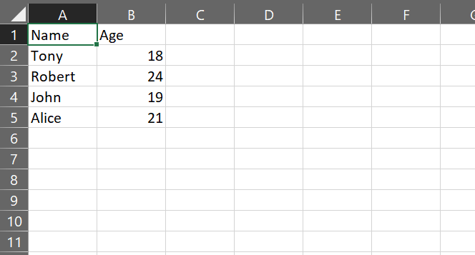
Example 2.19
#Example 2.19
#pip install xlsxwriter
import pandas
df = pandas.read_excel('test.xlsx', sheet_name='Sheet1')
print(df)



